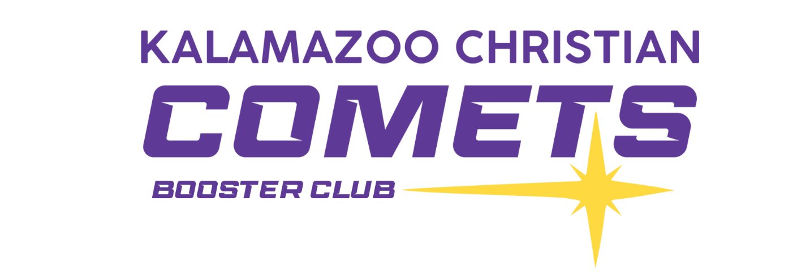
Game Day Sponsors
Support the teams that support your teams!
(click on the supporter to be taken to their website)

Advantage Outdoor Services Inc.
Buist Electric
CD Lawncare
Consumers Concrete
Culvers
Fairlife Milk
Farm Bureau Insurance
Fawley Overhead Door
Joldersma & Klein Funeral Home
Kalamazoo Christian Schools Foundation
Michaels Auto Service
Modderman Builders LLC
Persons Auto Repair
Premier Granite
Steensma Lawn & Garden
Toms Greenhouse
Unified Engineering
Vandersalms Flower Shop
Wenke Flooring & Design
Willis Sports
Wolverine Lawncare

